**Warehouse Manage Software Proposal**

Contents

**1.** **Purpose** 2

**2.** **Design** 4

**2.1.** **Import** 5

**2.2.** **Export** 5

**2.3.** **Warehouse & Stock Manage** 6

2.3.1. Structure of Warehouse: Warehouse dashboard 6

2.3.2. Material and BOM Manage 6

2.3.3. Stock Import comparison 6

2.3.4. View & Manage stock in warehouse 6

2.3.5. Manage Mother Warehouse 6

2.3.6. Compare Stock 6

2.3.7. Demand checking 6

2.3.8. Material Moving 6

2.3.9. Material Scrap 6

**2.4.** **Finance Module:** 7

**3.** **Schedule** 7

**4.** **Costing Forecast** 8

1. **Purpose**

Target is “Manage material in warehouse”:

* Allow user tracking for import and export transaction.
* Allow user manage stock in warehouse.
* Allow user manage group warehouse, sub warehous:
  + This mean application will support for manage 1 or many sub warehouse insize an others warehouse.
  + User can view, process, manage stock of mother warehouse or single warehouse
* Allow user compare, recognize difference quantity stock between ECUS and SAP.
* Need support current process:



Base on that this module will help user:

* Have a good view for all warehouse status
* Have soon detection the difference stock between SAP & ECUS
* User will have good plan for reduce the defference stock between SAP & ECUS

1. **Design**

This software will have 4 main modules:

* Import
* Export
* Stock Manage
* Finance



* 1. **Import**

This module will manage, tracking all import activity:

* This module allows user import list of Declaration.
* This module allows user view, search information of Declaration.
* This module allow user create report about importation in period time.
* This module support for process “Declaration” for input inventory into warehouse
* Support for request “1. Nhập Khẩu”
  1. **Export**
* This module will manage, tracking all export activity:
* This module allows user import list of Declaration.
* This module allows user view, search information of Declaration.
* This module allow user create report about importation in period time.
* This module support for process “Declaration” for liquidation
* Support for request “1. Nhập Khẩu”

**Note:** The process functions in module Import and Export will support for liquidation. Calculate stock in single warehouse. This support for Requirement:

* 3.a Thanh lý KD
* 3.b Thanh Lý SXXK
  1. **Warehouse & Stock Manage**

This is main module in this application. This will support:

* + 1. Structure of Warehouse: Warehouse dashboard
  + One warehouse allows have one or many smalls sub warehouse.
  + User able to create the warehouse structure:
    - Create new warehouse.
    - Assign relationship of warehouse, mother warehouse.
    - Mapping “Declaration Code” with owner warehouse. This use for process “Declaration”. When processing “Declarations”, material will auto count for owner warehouse.
    1. Material and BOM Manage
  + This Module will link with data of Material Mange for get information of BOM, Material List.
  + Need improve Material List to get data from ECUS through Excel file.
  + Need to create new module for manage APAC BOM, Fru Pick Pack BOM…
    1. Stock Import comparison
  + Import inventory stock into warehouse.
  + This support for manage current stock in ECUS and SAP. Use for comparison.
    1. View & Manage stock in warehouse

This module will allow user manage inventory in warehouse.

* + 1. Manage Mother Warehouse
  + Mother warehouse is warehouse have sub warehouse inside.
  + This module will help calculate inventory in this warehouse only, ignore sub module inside.
  + This module helps to calculate total inventory of this module with sub module inside.
    1. Compare Stock
  + This module support comparing inventory stock between two warehouses.
  + This module use for compare inventory stock between SAP & ECUS
  + The result of this module will help to give decision for adjust “rate of lost” or swap item in BOM
    1. Demand checking
  + When user needs to export goods or material, user need check the status of inventory for this material is available for export or not.
  + This module will user can know in warehouse have enough inventory for export. Or we need get inventory from other warehouse.
    1. Material Moving
  + This module support for tracking material moving from warehouse to other warehouse
  + Item “Demand Checking” & “Material Moving” will support for requirement
    - 4.a Check Tồn KD
    - 4.b Check Tồn SXXK
    - 4.5 Chuyển loại hình
    1. Material Scrap
  + Support for Scrap item need to ask: “Do ECUS Support this feature?”
  + But SAP have this feature, so we need to
  1. **Finance Module:**
* This module will support for calculate tax.
* This support requirement “5. Tính Thuế”

1. **Schedule**

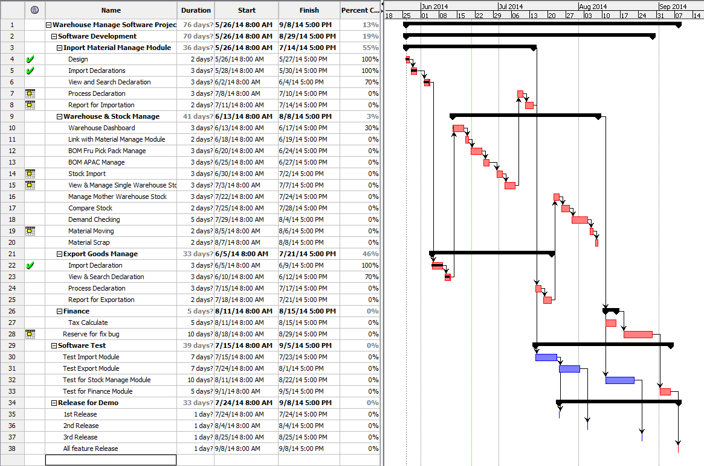

1. **Costing Forecast**

|  |  |  |  |  |
| --- | --- | --- | --- | --- |
| **Warehosue Manage Software Costing Forecast** | | | | |
| No. | Module Name | Cost | PIT (Thuế TNCN) | Total |
| 1 | Import Module | 8,000,000 | 800,000 | 8,800,000 |
| 2 | Warehosue Stock Manage | 20,000,000 | 2,000,000 | 22,000,000 |
| 3 | Export Module | 8,000,000 | 800,000 | 8,800,000 |
| 4 | Finance | 6,000,000 | 600,000 | 6,600,000 |
| 5 | Onsite Support | 5,000,000 | 500,000 | 5,500,000 |
| Total | | | | 51,700,000 |